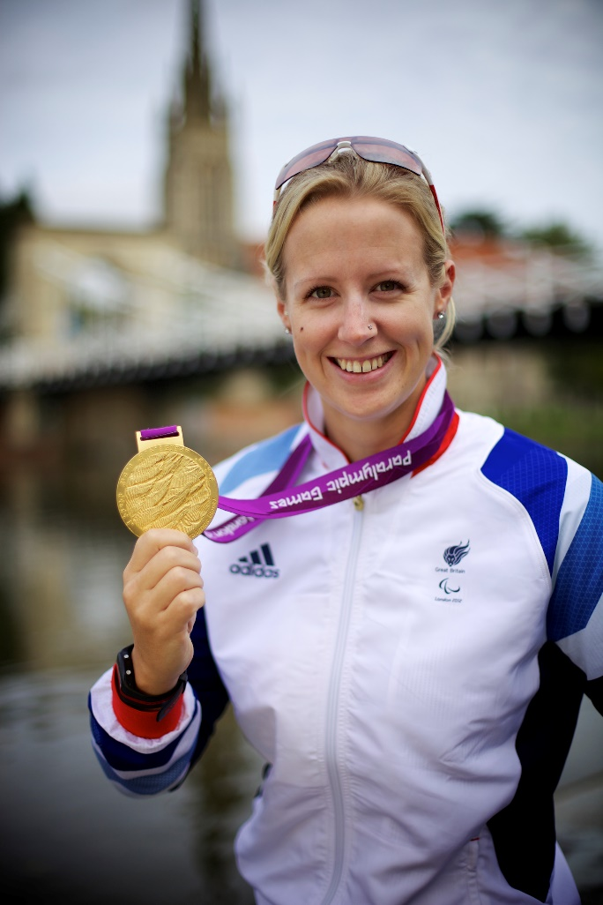**Naomi Riches MBE**  
  
At the 2012 London Paralympic Games Naomi Riches achieved what some athlete’s only dream of; winning a Gold Medal at a home Games.   
  
Born in 1983, Naomi was diagnosed at just 8 weeks old with a Visual Impairment; her parents knew that from day one this would lead to many difficulties and challenges.

During her years in mainstream school Naomi was severely bullied which lead to a total lack of self-confidence; this lead to Naomi underachieving and quite ironically showing no interest what so ever in school sport.   The only subject Naomi felt really comfortable with was Art, this baffled her teachers as Naomi's dream was to be an artist.

Naomi followed this creative dream and was mid-way through a Jewellery and Metalworking Degree when she was offered the chance to try out for the Great Britain Adaptive Rowing Team. Naomi seized the opportunity as she has tried rowing briefly at College and just 4 months later Naomi became a World Champion in Great Britain’s Mixed Coxed Four.

Over the next 10 years Para-Rowing developed into a full time Lottery Funded Paralympic Sport, making its debut at the 2008 Beijing Games.  Naomi was a key driver in the development of Para-Rowing over those 10 years, winning 6 World Championship Titles, a Bronze at the Beijing Games and a Gold in London.   Her journey was by no means easy but her resilience, her ability to adapt and work within the ever changing team and to see the positives in the world around her, along with her determination to be at the top of her sport, kept her fighting.  
  
Now retired from full time Sport, Naomi is keen to use what she has learnt to motivate, inspire and enable others.